Table of Contents
EXECUTIVE SUMMARY 3
INTRODUCTION 3
Challenges/ Problems 6
Purpose of the report 8
Stakeholder Analysis 8
Assessment and analysis with secondary data 11
Recommendations 11
CONCLUSION 20
REFERENCES 23

EXECUTIVE SUMMARY
The report highlights the accelerating technological issues in the McKinsey & Company. It challenges a transformative instant demanding strategic quickness and innovative expertise. As the consulting business observers, a seismic change is determined by developing technologies such as automation, machine learning, and artificial intelligence. McKinsey is bound to reconsider its business strategy, talent acquisition policies, and client involvement models. The challenges are diverse: McKinsey's consultants should quickly implement to new apparatuses and methodologies. It safeguards their capability to bring cutting-edge resolutions that vibrate with clients' growing needs. Simultaneously, clients are progressively expecting technology-determined understandings and recommendations to challenge multifaceted business encounters. This requires McKinsey's nonstop improvement of its technological abilities and proficiency. The sentiment of this version depends on the authority of talent procurement and growth. McKinsey must fascinate and retain top talent capable of developing technologies. While also capitalizing on inclusive training and growth programs to upgrade skilled current consultants. Besides, the presence of disintermediation emerges great, as digital stages and self-service analytics apparatuses impend to interrupt old-style consulting models. McKinsey must distinguish the problem by presenting modified, value-added amenities that power technology and strategic visions to solve clients' unique requirements and challenges. The report evaluates the impact of research on internal and external stakeholders. The research of this report has the conceivable to have a significant influence on similarly internal and external stakeholders linked with McKinsey & Company.
This coming together of challenges is complicatedly consistent with current affairs and business tendencies. The COVID-19 pandemic has assisted as a compound for faster digital transformation diagonally segments, intensifying the request for technology-empowered consulting facilities. McKinsey must direct this scene by powering its proficiency to provision clients' digital drives and adaptive flexibility in the appearance of uncertainty. Concurrently, the explosion of statistics analytics and AI offerings mutually opportunities and issues for McKinsey. It permits the firm to originate actionable understandings and improve decision-making procedures while also requiring cautious direction finding of ethical and controlling deliberations. Among these shifts, McKinsey looks to increased competition from technical entities such as IBM, Amazon, and Google. It increases their occurrence in the consulting business, powering their technological ability to propose straight services to customers. To preserve its competitive advantage, McKinsey must distinguish itself over innovation, business agility, and a persistent commitment to bringing tangible worth to customers.
Considering these challenges and chances, numerous strategic recommendations arise. McKinsey should capitalize deliberately on technological competencies and proficiency. It lines up talent acquisition exertions with evolving trends and client requirements. The firm must adopt an innovation culture and experimentation, authorizing consultants to grip developing technologies and value-added resolutions with clients. The difference is key: McKinsey must power its profound industry proficiency and strategic understanding to propose personalized, technology-determined recommendations custom-made to clients' detailed frameworks and challenges. Furthermore, the firm must continue attentive in solving regulatory and ethical deliberations. This safeguarding obedience with data secrecy rules and ethical values while connecting the control of technology to determine meaningful influence.

INTRODUCTION
In the dynamic environment of the management consulting firm, McKinsey & Company positions as an ideal of innovation and strategic insight. However, in the aspect of quick technological disruptions, the company looks at a key instant necessitating adaptation and anticipation. The consultancy report discusses separating the challenges and chances accessible by technological progressions for McKinsey (Agboola, 2023). The report offers an actionable understanding to direct the difficulties of the digital phase. Initially, the report will contextualize the ever-changing aspects of the consulting business among the persistent hike of technological development. Secondly, it will discover the current problems troubling McKinsey, since economic fluctuation to geopolitical pressures and the authority to participate in developing technologies in consulting applies. Lastly, the report will summarize an organized analysis, presenting strategic recommendations to solve these challenges and exploit the opportunities accessible by technological disturbances. The client can capture to advance a comprehensive consideration of McKinsey's reply to technological challenges, sideways with legal understandings to direct strategic policymaking and improve client value (Bejjani, 2023). By dismembering the details of McKinsey's variation to technological disturbances, this report goals to prepare internal and external stakeholders with the information and tools required to flourish in a progressively digital environment.

Figure 1: McKinsey Profile
(Source: World Economic Forum, 2024)
In addition to discovering McKinsey's reply to technological troubles, the report will inspect how these issues are consistent through current affairs, like the pandemic of COVID-19 or geopolitical pressures. By contextualizing McKinsey's problems inside wider international trends, the client will capture a strong understanding of the outside forces determining the consulting business. Additionally, the report will summarize a roadmap for McKinsey's upcoming strategy. It highlights the main areas of emphasis and possible paths for innovation. Eventually, clients can imagine from this report a complete interpretation of McKinsey's place in the digital era and actionable recommendations to direct the difficulties of the changing business environment.

Challenges/ Problems
In analysing the challenges met by McKinsey & Company, it is vital to reflect on mutually current issues entrenched in current affairs and possible future problems that may arise because of constant trends. McKinsey, as a foremost management consultancy, directs a multifaceted scene inclined by numerous features, with geopolitical changes, economic doubts, and technological interruptions.
Existing Challenges:
McKinsey looks at numerous existing challenges restricting since current affairs, with:
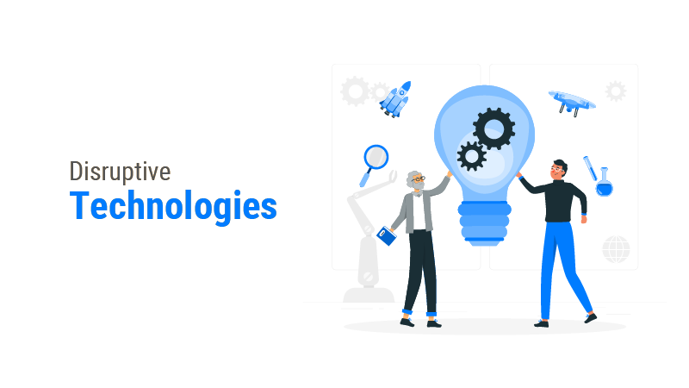
Figure 2: Technological Disruptions
(Source: Clayslays Technology, 2023)
- Technological Disruptions: Quick progressions in technology are redesigning industries and renovating business models (Calderon-Monge, 2023). McKinsey must struggle with the issues of participating in developing technologies for its consulting applies while safeguarding that its advisors hold the essential skills and proficiency to bring innovative resolutions to clients. Disappointment to acclimatize to technological disturbances can impact McKinsey's competitive benefit and reduce its significance in the market.
- Economic Uncertainty: The worldwide economic scene is considered by instability and ambiguity, intensified by events like geopolitical pressures and the COVID-19 pandemic. Economic recessions and market instabilities can influence McKinsey's customer base. It is foremost to condensed demand intended for consulting services and the burden on fee constructions. McKinsey must direct these fears while keeping effectiveness and bringing worth to clients.
- Geopolitical Tensions: The geopolitical pressures and trade disputes stance risks to McKinsey's global operations. Political unpredictability and regulatory variations in main markets can disturb client schedules and influence project timelines and productivity. McKinsey must track geopolitical growth closely and acclimate its business strategies to moderate risks and exploit developing opportunities.
Connection to Current Affairs:
The current challenges met by McKinsey are carefully associated with current affairs and constant trends in the international business environment:
- COVID-19: The COVID-19 pandemic has quicker digital transformation inventiveness and redesigned customer behavior and market forces at work (Cardinali, 2023). McKinsey must support clients in directing the encounters of remote work, unstable customers, and preferences supply chain disturbances although also acclimating its processes to remote consulting and computer-generated teamwork.
- Trade Wars and Protectionism: Trade pressures among main economies have controlled augmented ambiguity and unpredictability in worldwide markets. McKinsey's customers may look at challenges associated with supply chain disturbances, trade blocks, and geopolitical dangers. McKinsey must offer strategic direction to aid clients moderate these risks and classify new development opportunities in a progressively undefined geopolitical atmosphere.
- Increase of ESG (Environmental, Social, and Governance) Fears: Rising consciousness of environmental and social problems is pouring demand for sustainable commercial applications and ethical business governance (Dell'Acqua, 2023). McKinsey must guide clients on participating in ESG deliberations in their strategic policymaking procedures and aid them in directing regulatory necessities and stakeholder prospects associated with sustainability and corporate accountability.
Possible Future Challenges:
Looking forward, McKinsey may look at supplementary challenges because of developing trends and constant expansions in the worldwide business environment:
- Sustainability and Climate Change: Climate change poses important risks to trades transversely industries, from physical disturbances to regulatory burdens and reputational dangers. McKinsey must support clients in emerging strong sustainability policies and flexibility plans to moderate the influence of climate-related dangers and exploit opportunities linked with the change to a less-carbon economy.
- Rising Competition: The consulting sector is becoming progressively crowded, with new competitors and niche entities exciting McKinsey's marketplace supremacy. McKinsey must distinguish itself by transporting exclusive value propositions, powering its profound industry proficiency, and capitalizing on cutting-edge abilities to remain ahead of the competition.
- Digital Change and Interruption: The stage of digital transformation is hastening, and ambitious because of developments in technologies like the Internet of Things, blockchain, and artificial intelligence (Fleming, 2023). McKinsey must do in advance the disruptive possessions of digital change on traditional businesses. It aid clients in acclimating their business representations, procedures, and company structures to succeed in the digital age.

Purpose of the report
The main purpose of this report is to examine the current challenges and possible upcoming risks met by McKinsey & Company, mainly in relative to economic fluctuation, geopolitical pressures, and technological disturbances. By estimating these specific problems, the report goals to offer actionable understandings and deliberate recommendations that will empower McKinsey to direct the difficulties of the international business environment successfully. The report also analyzes internal and external stakeholder impact (Guerra, 2023). Eventually, the report aims to provide McKinsey in preserving its competitive benefit, improve client worth, and sustain long-term achievement in the changing consulting industry.

Stakeholder Analysis
Stakeholder Recognition:
Internal Stakeholders:
- McKinsey's Leadership Team: Together with the CEO, senior management, and executive board members accountable for strategic policymaking.
- McKinsey Consultants: Consultants transversely numerous levels inside the company who are straightly combined in client arrangements and executing strategic inventiveness.
- Human Resources Department: Accountable for talent procurement, training, and development plans to provision the company’s employees.
External Stakeholders:
- Clients: Administrations crosswise industries that involve McKinsey intended for consulting facilities to discourse strategic problems and opportunities.
- Investors: Financial shareholders and shareholders concerned with the organization's performance, success, and long-term development projections.
- Industry Peers: Challenging consulting companies and industry companies who may be obstructed by McKinsey's policies and market position.
- Controllers and Government Agencies: Government agencies and regulatory bodies that supervise the consulting business may affect McKinsey's processes over strategies and regulations.
- Community and Society: The larger community and society are obstructed by McKinsey's activities and decisions, with aids to economic development, job formation, and social accountability inventiveness.
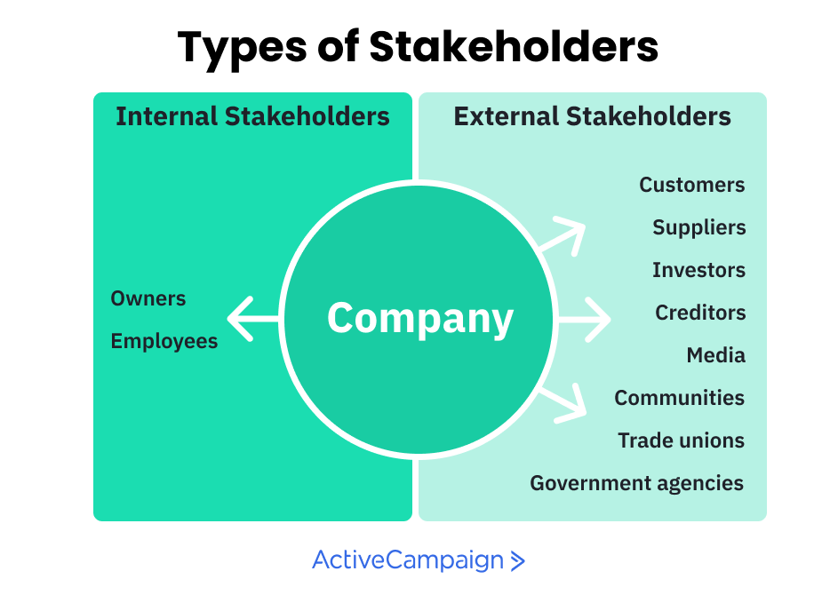
Figure 3: Stakeholders Types
(Source: Active Campaign, 2021)
Connection to Stakeholders:
Internal Stakeholders:
- Leadership Team: The analyses and recommendations of the report straightly impact strategic policymaking procedures inside McKinsey. It determining the company’s reply to technological disturbances and supervisory resource distribution and investment urgencies.
- Consultants: The understandings created from the research update consultants' empathy of market forces at work and client requirements (Hauge, 2023). This empowers them to improve service distribution and grow innovative resolutions that encounter developing client expectations.
- Human Resources Department: The report's references may affect talent procurement policies, training plans, and organizational growth initiatives. This intended to prepare McKinsey's employees with the skills and abilities required to direct technological disturbances efficiently.
External Stakeholders:
- Clients: The report's visions aid clients in recognizing McKinsey's tactics for solving technological disturbances and its suggestions for their businesses (Lasrado, 2023). It can improve effective client relation, improve trust and self-assurance. McKinsey's capability carry value-added resolutions personalized to their precise requirements.
- Investors: Investors practice or use the data presented in the report to estimate McKinsey's strategic position, growth predictions, and long-lasting sustainability. Positive consequences from the report may chief to augmented investor self-confidence and provision for McKinsey's deliberate creativities.
- Industry Peers: Challenging consulting businesses may track McKinsey's replies to technological interruptions to standardize their approaches and inventiveness. The report's conclusions can impact industry forces at work and competitive placement inside the consulting segment.
- Regulators and Government Agencies: Government agencies and regulatory bodies may reflect the report's references when expressing policies and guidelines affecting the consulting sector. McKinsey's active method to solve technological disruptions may subsidize to larger debates on industry morals and best applies.
- Community and Society: McKinsey's actions and choices, knowledgeable by the report's understandings. It can have a wider influence on the public and society. It contains aids to economic development, job formation, and social accountability creativities that advantage local people and society at huge.
Evaluation of Influence on Stakeholders:
The research directed for this report can have an important influence on equally internal and external stakeholders connected with McKinsey & Company. By offering valuable understandings and strategic references directed to solve technological distractions. The report improves decision-making procedures inside McKinsey and supports relations with clients, stakeholders, industry peers, investors, and the community (Mollah, 2023). Through active engagement and teamwork with stakeholders, McKinsey can power the conclusions of this report to determine positive consequences, adopt innovation, and endure long-term achievement in a quickly shifting business environment.

Assessment and analysis with secondary data
In evaluating the current problems and possible future risks met by McKinsey & Company, the PESTEL framework is used with the help of secondary data. The report mainly analyses problems faced by the client are economic variations, geopolitical burdens, and technological instabilities (Koskelainen, 2023). This framework permits to systematic evaluate the external factors affecting McKinsey's business situation and recognize strategic replies to moderate risks and exploit opportunities.
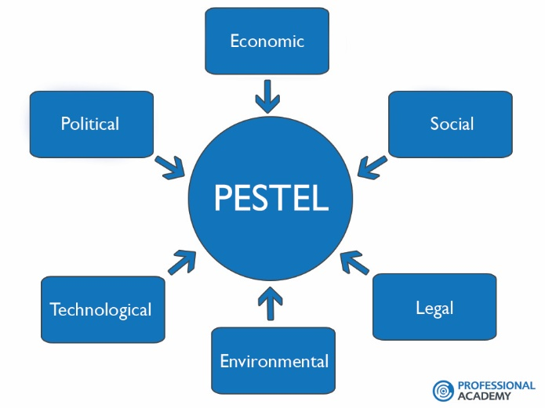
Figure 4: PESTEL Framework
(Source: Professional Academy, 2024)
Economic Fluctuations:
Economic fluctuations, like currency volatility, inflation, and recessions, carriage important challenges to McKinsey's processes (Pascucci, 2023). By the PESTEL framework, it can estimate the economic aspects disturbing McKinsey's business environment:
- Recession Risk: Economic recessions can cause to decrease in demand for consulting services using businesses cutting costs and interrupting strategic inventiveness. McKinsey must track the possible influence of downturns on client financial plans and change its service contributions consequently.
- Inflationary Pressures: Inflationary burdens can impact profit margins and raise operating budgets for McKinsey, affecting effectiveness and financial performance. The organization must execute cost-saving actions and pricing approaches to moderate the properties of price rises on its lowest line.
Geopolitical Burdens:
Geopolitical burdens, like trade arguments, regulatory deviations, and political unpredictability, can interrupt McKinsey's worldwide operations and client arrangements. The PESTEL framework can evaluate the geopolitical aspects manipulating McKinsey's business environment with the help of secondary data:
- Trade Arguments: Trade pressures among main economies can disturb McKinsey's international processes, foremost due to vagueness and market instability (Oladoyinbo, 2023). McKinsey must track geopolitical growths carefully and acclimatize its approaches to moderate risks and exploit evolving opportunities.
- Regulatory Fluctuations: Regulatory changes, like data secrecy laws and trade contracts, can influence McKinsey's capability to perform business in certain marketplaces and industries. The organization must safeguard obedience with regulatory necessities and direct legal difficulties to preserve its status and integrity.
Technological Instabilities:
Technological instabilities, like disorderly innovations and digital conversions, are redesigning the consulting business and challenging old-style business representations. Using the PESTEL framework with secondary data, the report analyses the technological aspects manipulating McKinsey's business environment:
- Disruptive Innovations: Evolving technologies, like blockchain and artificial intelligence, are changing consulting methods and client outlooks. McKinsey must hold innovation and capitalize on technological competencies to persist competitive in a fast-developing landscape.
- Digital Transformations: The change to digitalization is pouring demand for technology-enabled consulting services like cybersecurity, data analytics, and digital strategy. McKinsey must acclimate its service contributions to meet the developing requirements of clients and distribute value-added resolutions in the digital stage.
Critical Valuation and Insights:
Considering the challenges and risks recognized over the PESTEL analysis through secondary research. McKinsey must accept an active and adaptive method to directing the difficulties of the worldwide business environment. By powering its strengths in business expertise, thought leadership, and worldwide network, McKinsey can moderate risks and exploit opportunities to endure long-term achievement.
Additionally, McKinsey should emphasize on improving teamwork, strategic corporations with clients, business peers, and other shareholders to determine innovation and adaptive flexibility in the appearance of technological, geopolitical, and economic interruptions. By nurturing a philosophy of innovation, agility, and nonstop learning, McKinsey can place itself as a reliable advisor and strategic companion to clients, serving them to direct ambiguity and attain sustainable development in a quickly changing business world.
Eventually, the critical valuation and understanding resulting from the PESTEL examination offer valuable direction for McKinsey's planned decision-making procedures. This allows the firm to pilot the challenges and exploit the opportunities accessible by economic variations, geopolitical burdens, and technological turbulences (Pearlson, 2024). By accepting change and adjusting to developing market-changing aspects, McKinsey can preserve its competitive benefit, improve client worth, and attain long-term success in the active consulting business.
This section of the report conducts a complete examination of secondary data to solve the purpose of the report. The purpose of the report is to analyze the issues and opportunities accessible by technological interruptions for McKinsey & Company. The report will critically estimate numerous sources of information, with market analyses, financial data, and industry reports, to capture an understanding of McKinsey's reply to technological interruptions and their consequences for the consulting business.
1. Market Analysis and Industry Trends:
Technological Interruptions in the Consulting Business:
As per the report through Grand View Research, the worldwide management consulting facilities market extent was esteemed at USD 140.12 billion in 2020 and is predicted to rise at a composite annual growth rate (CAGR) of about 4.1% from 2021 to 2028 (Grand View Research, 2021). The development is accredited to cumulative demand for consulting amenities connected to strategic preparation, data analytics, and digital conversion, determined by technological interruptions across businesses.
The growth course lines up with conclusions through the Global Consulting Market Report of 2021 from Source Global Research, that underscore an important rise in demand for digital conversion services, mainly in reply to COVID-19 (Source Global Research, 2021). The report highlights the rising reputation of technology-determined consulting resolutions in serving companies acclimate to remote working, quickened digitalization exertions, and direct disruptions instigated by the COVID-19 pandemic.
McKinsey's Market Position:
Analysis of market segment information from IBISWorld discloses that McKinsey & Company upholds a leading place in the worldwide management consulting amenities market, with a projected market segment of around 10.5% (IBIS World, 2021). Contempt opposite growing competition by boutique consulting entities and tech organizations. McKinsey's brand status, industry proficiency, and worldwide reach remain to differentiate it as a front-runner in the consulting segment.
2. Strategic Inventiveness and Financial Performance:
Revenue Development and Profitability:
Financial reports of McKinsey show stable revenue development over the previous five years, through an entire revenue success of USD 10.5 billion in 2020 (Mckinsey & Company, 2020). However, profit boundaries have met the burden because of increasing operating costs and capitalization on technology and employee development.
As per McKinsey's Yearly Report 2020, the organization's revenue development was determined by augmented demand for digital conversion facilities, mainly in segments like healthcare, financial amenities, and technology. McKinsey's strategic creativities to enlarge its digital abilities and capitalize on innovative resolutions have subsidized to its capability to gain market chances and bring value to customers.
Investment in Innovation and Technology:
McKinsey's yearly reports underscore important investments in innovation and technology initiatives intended to improve client value and pour operational efficacy. The investments contain the growth of proprietary analytics apparatuses, digital stages, and AI-driven explanations to bring data-driven understandings and deliberate references to clients.
As per the Future of Work, The McKinsey Global Institute's report underlines the significance of technology in redesigning the consulting business and pouring productivity advances. The report underscores the possibility for automation, machine learning, and AI to supplement human abilities and empower more effective and operative decision-making procedures in consulting arrangements (Mckinsey Global Institute, 2019). McKinsey's strategic capital investments in technology line up with these discoveries, positioning the organization to exploit developing chances in the digital environment of consulting.
3. Client Satisfaction and Engagement:
Client Satisfaction and Feedback Surveys:
Examination of client satisfaction and feedback surveys discloses optimistic trends in McKinsey's client involvement and satisfaction stages. Clients escalate McKinsey's capability to offer innovative resolutions directed to their precise requirements and challenges, powering technology and business expertise to carry measurable outcomes.
Net Promoter Score (NPS) metrics of McKinsey show positive levels of customer satisfaction and faithfulness, through most clients communicating inclination to mention McKinsey's services to family and friends. The organization's prominence on teamwork, transparency, and value distribution vibrates with clients, nurturing long-term corporations and repeat actions.
Case Studies and Achievement Stories:
Analyzing case studies and achievement stories since McKinsey's services portfolio covers the organization’s track record of distributing additional value to clients by successful application of technology-determined resolutions (Qudah, 2023). Instances contain digital transformation inventiveness, data analytics work, and strategic rearrangements that have led to better-quality performance and competitive benefits for client administrations.
4. Talent Development and Acquisition:
Recruitment and Training Plans:
Statistics of McKinsey's human resources branch display continuing recruitment exertions to appeal to top employees with proficiency in developing technologies and digital conversion. Moreover, the organization invests in inclusive training and development plans to upgrade the skills of present consultants and prepare them with the competencies required to direct technological disruptions successfully.
McKinsey's obligation to employee acquisition and growth is replicated in its recruitment approaches, that highlight leadership skills, inclusion, and diversity. The organization's recruitment measures, training plans, and mentorship agendas offer consultants chances to improve their skills, enlarge their networks, and develop their careers inside the firm.
Employee Retention and Satisfaction:
Employee satisfaction inspections show huge levels of involvement and job satisfaction between McKinsey consultants (Schmitt, 2023). The organization's emphasis on nurturing a philosophy of innovation, teamwork, and non-stop learning subsidizes solid employee retention rates and a consistent team atmosphere.
McKinsey's focus on work-life stability, professional growth, and opportunities for development and advancement vibrates with consultants, foremost to optimistic feedback and an intellect of loyalty toward the firm (Rahman, 2023). The organization's exertions to produce a supportive and comprehensive work setting subsidize its capability to fascinate and retain top talented employees in a competitive marketplace scene.
Critical Assessment and Insights:
The examination of secondary data offers a valuable understanding of McKinsey's reply toward technological disruptions and its suggestions for the consulting business. Whereas McKinsey preserves a solid marketplace and status for bringing value to customers. It looks at challenges associated with growing competition, profit margin burdens, and the necessity to nonstop innovate in reply to changing client demands.
Additionally, the evaluation discloses the significance of strategic capital investments in technology and employee expansion to determine future development and preserve competitiveness. McKinsey's obligation to innovation and customer-centricity places it well to exploit developing opportunities in the digital environment of consulting. However, the organization must continue vigilant in solving challenges connected to talent retaining, operational effectiveness, and differentiation in a competitive marketplace.
The overall analysis underlines the vital role of technological implementation and strategic business quickness in McKinsey's mission to direct the difficulties of the consulting business and sustain long-term achievement among technological disruptions.
Using the McKinsey 7-S Model, research profounder in the critical valuation and insights collected from the inspection of secondary data about McKinsey's reply to technological disruptions and its suggestions for the consulting business.
McKinsey 7-S Framework:
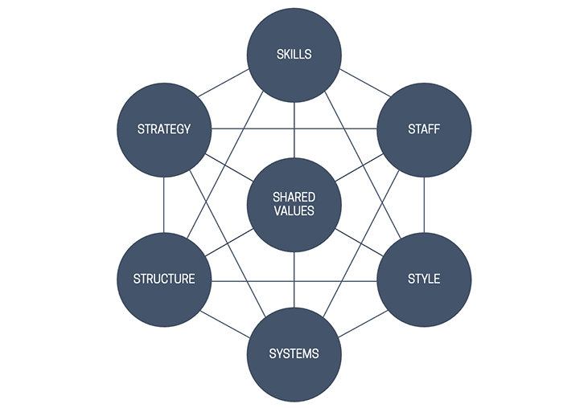
Figure 5: McKinsey 7-S Framework
(Source: MBA Management Models, 2021)
- Strategy:
McKinsey's deliberate reply to technological interruptions involves powering its business expertise and worldwide network to classify developing trends and opportunities. By emerging innovative resolutions and digital abilities (Trincado-Munoz, 2023). McKinsey's goals are to preserve its competitive advantage and improve client value among developing market-changing aspects.
- Structure:
McKinsey's company structure highlights agility and teamwork, allowing cross-operational teams to acclimate speedily to shifting client requirements and market environments. The organization's matrix structure enables information sharing, resource distribution, nurturing innovation and receptiveness to technological disturbances.
- Systems:
McKinsey's systems and procedures provision non-stop learning and data management, permitting consultants to remain up-to-date on the newest technological progressions and best applications (Shaddiq, 2023). The organization's investment in digital stages and analytics apparatuses improves data-driven policymaking and permits consultants to bring understandings and recommendations with swiftness and accuracy.
- Shared Values:
At the fundamental of McKinsey's firm culture are values of brilliance, honesty, and customer-centricity. The shared values direct employees in their communications with customers and classmates. This nurtures a culture of faith, teamwork, and innovation. McKinsey's obligation to bring measurable outcomes and surpass client expectations determines its achievement in directing technological interruptions.
- Style:
McKinsey's leadership style highlights authorization and responsibility, inspiring consultants to yield ownership of their ventures and chase innovative resolutions (Shodiyevich, 2023). Leaders offer mentorship and provision to foster talent and enable a culture of non-stop development and knowledge.
- Staff:
McKinsey's investment in employee acquisition and growth safeguards varied and skilled employees capable of solving multifaceted client problems. The organization recruits top employees from varied backgrounds and advances in training and growth plans to prepare consultants with the assistance and knowledge required to prosper in a digital atmosphere.
- Skills:
McKinsey's consultants hold a varied set of skills, with analytical skills, industry proficiency, and communication assistance. The firm raises a culture of non-stop learning and skill growth. It permits consultants to acclimate to technological interruptions and bring value-added resolutions to clients.
The execution of the McKinsey 7-S Model underscores McKinsey's strategic arrangement and organizational willingness to pilot technological interruptions in the consulting business. By directing on skills, style, systems, shared values, structure, staff, and strategy, McKinsey can successfully reply to developing marketplace trends and preserve its leadership place in the digital phase of consulting.

RECOMMENDATIONS
The main key purpose of this assignment was to inspect the challenges met by technological interruptions in McKinsey & Company and offer practical recommendations to direct these challenges successfully (Van Doorn, 2023). By evaluating secondary data and directing a critical assessment, the report intended to propose an understanding of McKinsey's reply to technological interruptions and its execution for the consulting business.
Recommendations:
- Investment in Technological Abilities: McKinsey must arrange deliberate investments in technology to improve its digital abilities and continue at the lead of innovation. It contains evolving proprietary analytics apparatuses, AI-driven resolutions, and digital stages to bring data-driven visions and value-added facilities to clients. By powering innovative technologies, McKinsey can distinguish itself in the modest consulting business and solve developing client requirements more successfully.
- Emphasis on Talent Growth: McKinsey must continue to prioritize talent growth and invest in inclusive training and development plans to upgrade its counselors in developing technologies and digital conversion (Yaqub, 2023). By nurturing a culture of non-stop knowledge and innovation, McKinsey can authorize its employees to familiarise themselves with technological interruptions and bring high-quality resolutions to clients. Besides, initiatives like mentorship plans and leadership growth can aid in fostering future leaders and determine organizational development.
- Improved Client Engagement Approaches: McKinsey must improve its client appointment approaches by accepting a more custom-made and data-driven tactic. It contains powering progressive analytics and client relationship management (CRM) arrangements to advance deeper understandings into client likings and modify resolutions to meet their precise requirements. By firming client relations and bringing measurable outcomes, McKinsey can improve client satisfaction and faithfulness. Eventually pouring revenue development and marketplace competitiveness.
- Strategic Corporations and Teamwork: McKinsey must discover strategic corporations partnerships with technology corporations, startups, and the academic world to admittance cutting-edge knowledge or adaptive innovation. By cooperating with external shareholders, McKinsey can advance entree to focused expertise, quicken product growth, and enlarge its service aids to discourse developing marketplace trends and customer demands.
Incorporating Recommendations:
The recommendations are fixed in the examination of secondary data, that discovered the challenges. McKinsey faces in replying to technological interruptions while preserving its marketplace and status for bringing value to clients. By executing these recommendations, McKinsey can practically solve these challenges and exploit developing chances in the digital atmosphere of consulting.
Capitalizing on technological abilities will permit McKinsey to remain ahead of the curve and propose innovative resolutions to clients (Kumar, 2023). Moreover, concentrating on talent growth will ensure that McKinsey's employees are prepared with the skills and proficiency required to flourish in a quickly shifting business scene. Improved client engagement approaches will reinforce relationships and determine business development. While strategic corporations and partnerships will enable admittance to new technologies and marketplace insights.

CONCLUSION
From the above report, it has been concluded that a complete examination of McKinsey & Company's met issues to technological interruptions inside the consulting business. By inspecting main challenges, assessing stakeholder influences, examining secondary data, and presenting strategic references. The report solves the main purpose of the project to direct these interruptions successfully and endure McKinsey's long-term achievement.
Key Issues:
In Section 2, the report recognized critical issues facing McKinsey, with increasing competition, revenue margin burdens, and the requirement for nonstop innovation. These issues are intensified by technological interruptions, requiring proactive replies from McKinsey to preserve its marketplace and bring value to customers.
The purpose of the report, which is represented in Section 3, is to offer practical understandings and references to solve these challenges. By directing a detailed analysis of McKinsey's interior and exterior environment, it is designed to prepare the company with approaches to direct technological troubles and endure its competitive benefit.
Section 4, estimated the influence of the research on shareholders, identifying the status of McKinsey's customers, employees, and business peers. The recommendations are planned to improve stakeholder worth by solving main challenges and exploiting developing chances in the digital consulting site.
Section 5 offered a comprehensive assessment and examination of secondary data, prominence trends, marketplace changing aspects, and competitive burdens determining McKinsey's functioning environment. By producing data from varied sources, it expanded an inclusive consideration of McKinsey's issues and opportunities in the appearance of technological interruptions.
Addressing the Purpose of the Assignment:
The recommendations, accessible in Section 6, are directly associated with the determination of the report and built-in evidence-based examination. Initially, the report recommends that McKinsey capitalizes on technology to improve its digital abilities and stay competitive. This addresses the encounter of technological interruptions and highlights McKinsey's obligation to innovation.
Secondly, the recommendation emphasis on talent growth addresses the requirement for skilled professionals talented in directing technological variations. By capitalizing on employee training and mentorship agendas, McKinsey can encourage employees prepared to encounter developing client demands and determine organizational development.
Furthermore, the recommendation to improve client engagement approaches recognizes the significance of solid relations in supporting McKinsey's competitive benefit. By powering data analytics and CRM arrangements, McKinsey can bring personalized resolutions and surpass client outlooks, thus firming up client faithfulness and retention.
Finally, the recommendation to discover strategic corporations underlines McKinsey's obligation to partnership and knowledge distribution. By associating with technology organizations and academia, McKinsey can admittance cutting-edge proficiency and remain ahead of business trends. It improving its skill to bring value to customers and preserve marketplace leadership.
In short, the report has offered an inclusive examination of McKinsey's reply to technological interruptions and presented strategic recommendations to discourse key problems. By executing these recommendations, McKinsey can direct technological interruptions successfully and sustain its long-lasting achievement in the consulting business. The report assists as an appropriate direction for McKinsey to exploit evolving opportunities and preserve its leadership place in a quickly growing business environment.

REFERENCES

Active Campaign, 2021, Stakeholder Types[online]available through<https://www.activecampaign.com/blog/types-of-stakeholders >[accessed on 19 April 2024].

Agboola, O.P. and Tunay, M., 2023. Urban resilience in the digital age: The influence of Information-Communication Technology for sustainability. Journal of Cleaner Production, 428, p.139304.

Bejjani, M., Göcke, L. and Menter, M., 2023. Digital entrepreneurial ecosystems: A systematic literature review. Technological Forecasting and Social Change, 189, p.122372.

Calderon-Monge, E. and Ribeiro-Soriano, D., 2023. The role of digitalization in business and management: a systematic literature review. Review of managerial science, pp.1-43.

Cardinali, S and et.al., 2023. Digitalization processes in small professional service firms: drivers, barriers and emerging organisational tensions. Journal of Service Theory and Practice, 33(2), pp.237-256.

Clayslays Technology, 2023, Technological Disruption[online]available through<https://www.claysys.com/blog/disruptive-technology-examples/ >[accessed on 19 April 2024].

Dell'Acqua, F and et.al., 2023. Navigating the jagged technological frontier: Field experimental evidence of the effects of AI on knowledge worker productivity and quality. Harvard Business School Technology & Operations Mgt. Unit Working Paper, (24-013).

Fleming, P., 2023. “Never let a good crisis go to waste”: How consulting firms are using COVID-19 as a pretext to transform universities and business school education. Academy of Management Learning & Education, 22(3), pp.425-438.

Grand View Research, 2021, Management Consulting Services Market Size[online]available through< https://www.grandviewresearch.com/industry/technology>[accessed on 19 April 2024].

Guerra, J.M.M., Danvila-del-Valle, I. and Méndez-Suárez, M., 2023. The impact of digital transformation on talent management. Technological Forecasting and Social Change, 188, p.122291.

Hauge, J., 2023. Manufacturing-led development in the digital age: how power trumps technology. Third World Quarterly, 44(9), pp.1960-1980.

IBIS World, 2021, Management Consulting Services[online]available through<https://www.ibisworld.com/united-states/market-research-reports/management-consulting-industry/ >[accessed on 19 April 2024].

Koskelainen, T and et.al., 2023. Financial literacy in the digital age—A research agenda. Journal of Consumer Affairs, 57(1), pp.507-528.

Kumar, S. and Aithal, P.S., 2023. Tech-Business Analytics–A Review Based New Model to Improve the Performances of Various Industry Sectors. International Journal of Applied Engineering and Management Letters (IJAEML), 7(1), pp.67-91.

Lasrado, F., Thaichon, P. and Nyadzayo, M.W., 2023. Exploring the role of relationship management and relationship quality in B2B: empirical insights and future research directions. Journal of Business & Industrial Marketing, 38(5), pp.1055-1086.

Mollah, M and et.al., 2023. Exploring a pathway to sustainable organizational performance of South Korea in the digital age: The effect of digital leadership on IT capabilities and organizational learning. Sustainability, 15(10), p.7875.

MBA Management Models, 2021, McKinsey 7-S Framework[online]available through<https://www.mbamanagementmodels.com/mckinseys-7-s-framework/ >[accessed on 19 April 2024].

Mckinsey & Company, 2020, Annual Report[online]available through<https://www.mckinsey.com/featured-insights/2020-year-in-review >[accessed on 19 April 2024].

Mckinsey Global Institute, 2019, The Future of Workt[online]available through<https://www.mckinsey.com/featured-insights/future-of-work >[accessed on 19 April 2024].

Oladoyinbo, T.O and et.al., 2023. Evaluating and establishing baseline security requirements in cloud computing: an enterprise risk management approach. Available at SSRN 4612909.

Pascucci, F., Savelli, E. and Gistri, G., 2023. How digital technologies reshape marketing: evidence from a qualitative investigation. Italian Journal of Marketing, 2023(1), pp.27-58.

Pearlson, K.E., Saunders, C.S. and Galletta, D.F., 2024. Managing and using information systems: A strategic approach. John Wiley & Sons.

Professional Academy, 2024, PESTEL Framework[online]available through<https://www.professionalacademy.com/blogs/marketing-theories-pestel-analysis/ >[accessed on 19 April 2024].

Qudah, H and et.al., 2023. Islamic finance in the era of financial technology: A bibliometric review of future trends. International Journal of Financial Studies, 11(2), p.76.

Rahman, M.S., Bag, S., Gupta, S. and Sivarajah, U., 2023. Technology readiness of B2B firms and AI-based customer relationship management capability for enhancing social sustainability performance. Journal of Business Research, 156, p.113525.

Rakha, N.A., 2023. Navigating the Legal Landscape: Corporate Governance and Anti-Corruption Compliance in the Digital Age. International Journal of Management and Finance, 1(3).

Reis, J. and Melão, N., 2023. Digital transformation: A meta-review and guidelines for future research. Heliyon, 9(1).

Schmitt, M., 2023. Securing the Digital World: Protecting smart infrastructures and digital industries with Artificial Intelligence (AI)-enabled malware and intrusion detection. Journal of Industrial Information Integration, 36, p.100520.

Shaddiq, S. and Irpan, M., 2023. Governance of Human Resources Management in the Digital Era. Journal of Business and Management Studies, 5(3), pp.80-96.

Shodiyevich, R.S., Shodiyevich, R.S. and Berdiqul o’gʻli, U.S., 2023. ACCOUNTING ISSUES IN THE DIGITAL ECONOMY. CENTRAL ASIAN JOURNAL OF MATHEMATICAL THEORY AND COMPUTER SCIENCES, 4(6), pp.80-84.

Source Global Research, 2021, Global Consulting Market Report[online]available through<https://reports.sourceglobalresearch.com/portal/marketupdates >[accessed on 19 April 2024].

Trincado-Munoz, F and et.al., 2023. Digital transformation in the world city networks’ advanced producer services complex: A technology space analysis. Geoforum, p.103721.

Van Doorn, J and et.al., 2023. Organizational frontlines in the digital age: The Consumer–Autonomous Technology–Worker (CAW) framework. Journal of Business Research, 164, p.114000.

World Economic Forum, 2024, Mckinsey Profile[online]available through<https://www.weforum.org/organizations/mckinsey-company/ >[accessed on 19 April 2024].

Yaqub, M.Z. and Alsabban, A., 2023. Industry-4.0-Enabled digital transformation: prospects, instruments, challenges, and implications for business strategies. Sustainability, 15(11), p.8553.

